III. METHODS

B. Initial Analysis

3.) I(1) Testing

Unit Root Tests

To test for unit root stationary, primarily, the Augmented Dickey-Fuller (ADF) test was used. The ADF test checks for the presence of unit root in the time series. The hypothesis tests are summarized as follows:

Ho: yt ~ I(1), series contains a unit root
Ha: yt ~ I(0), series is stationary
where ε_{t} ~ i.i.d

The ADF test was implemented using adf.test within R (using the package “tseries”). To choose the lag input, the order obtained through an AIC vs. BIC calculation was used; subsequently, the lowest lag order was chosen.

Additionally, the Phillips-Perron test was added, using pp.test within R, to substantiate test results from the ADF test. The hypotheses are the same as those from the ADF test. Results of these tests are shown in Table 5. As shown, the p-values all show the rejection of the H_{o} for the presence of a unit root; thus, these states were determined to be stationary.

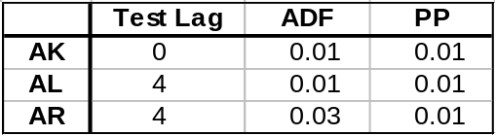
Table 5: p-values obtained from applying the Augmented Dickey-Fuller and Phillips-Perron tests to a sample of states

Using the GPH estimator as described above, d-parameters were estimated for the selected states. The results are shown in Table 2. Additionally, d-parameters were estimated using the Sperio estimator, to gauge the accuracy of GPH. Results using the Sperio estimator confirmed the d estimates for Alabama and Arkansas. However, the results for Alaska verified the need for further investigation.

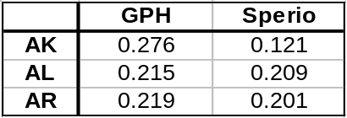
Table 2: d-parameter estimates using the GPH and Sperio esimates for a select sample of states

